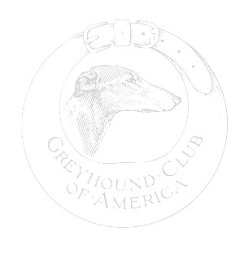

OWNER:

DOG’S NAME:
SIRE:
DAM:

- HEALTH REGISTRY INFORMATION:

- CONGENITAL ANOMALIES

- MEDICAL PROBLEMS

- CAUSE OF DEATH (as accurate as known):

AND AGE:

AUTOPSY: Y/N _____________

Submit the completed form to: Helen Hamilton
1543 Oslo Ct
Livermore CA 94550
925-371-2217
vims@sbcglobal.net

