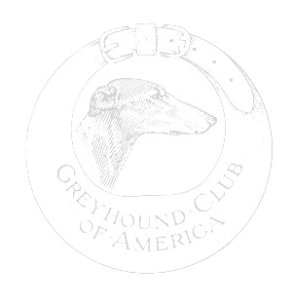

Greyhound Club of America

Versatility Awards

Nomination Form

Dog’s Name: _____________________________________________

Owner’s Name: _____________________________________________

Address: _____________________________________________

_____________________________________________

Phone Number: _____________________________________________

Email Address: _____________________________________________

Versatility Dog Nomination

- Date of Championship ____________________
- Date of ONE of the following three titles:
AKC Field Championship ____________________

NOFCA Coursing Championship ____________________

ASFA Field Championship ____________________

- Date of ONE of the following titles:
Companion Dog Title ____________________

Tracking Dog Title ____________________

AKC NA and NAJ Title ____________________

USDAA AD Title ____________________

NADAC NAC Title ____________________

For the Versatility Dog Award, the dog must hold one title in each category:
A, B & C.

Versatility Dog Excellent Nomination

In ADDITION to the requirements shown above for the Versatility Dog Title, the dog must have ONE of the following:

- Date of ONE of the following six accomplishments:

Group First Win ____________________

Specialty Best of Breed Win ____________________

ASFA Lure Courser of Merit Title ____________________

NOFCA Courser of Merit Title ____________________

Utility Dog Title ____________________

Tracking Dog Excellent Title ____________________

AKC AX and AXJ ____________________

USDAA MAD ____________________

NADAC EAC ____________________

For the Versatility Dog Excellent Award the dog must have one title in each category: A, B, C & D.

Submit the completed form to: Helen Hamilton
2443 Chardonnay Way
Livermore, CA 94550
vims@sbcglobal.net

