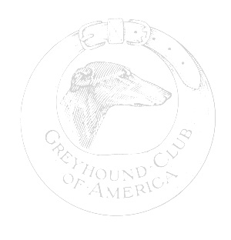
Health Survey

OWNER:

DOG’S NAME:
SIRE:
DAM:

- HEALTH REGISTRY INFORMATION:

- CONGENITAL ANOMALIES

- MEDICAL PROBLEMS

- CAUSE OF DEATH (as accurate as known):

AND AGE:

AUTOPSY: Y/N _____________

Submit the completed form to: Patti Clark
25 Point O Rocks Road
Newtown, CT 06470
203-426-3154
willomoor@att.net

